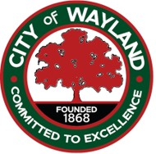

NOTICE OF WAYLAND CITY COUNCIL
FY 26/27 BUDGET WORKSHOP

NOTICE IS HEREBY GIVEN that the Wayland City Council will hold a Budget Workshop on Monday, May 11th, 2026, at 5 PM. Although the meeting is open to the public, there will be no opportunity for public comment. The workshop will be held at the City Hall, 103 S Main St., Wayland, Michigan 49348

This notice is posted in accordance with the requirements of the Open Meetings Act.

Dated May 6th, 2026 Amanda Rodriguez
City Clerk/HR Manager
City of Wayland
269-792-2265

